**EKVIRA TOWER FANS:**

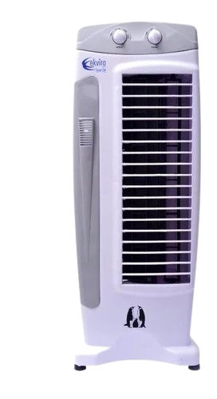

**Price: 8,000.00**

The Ekvira Tower Fan is a sleek and modern cooling solution, designed to provide quiet and efficient airflow in a compact, tower-style design. With its powerful motor and aerodynamic blades, this fan effectively circulates air, making it perfect for small to medium-sized rooms, such as bedrooms, offices, and living rooms. Its slim profile, adjustable speed settings, and energy-efficient design make it an ideal choice for those seeking a stylish and functional cooling solution.

**Key features of ekvira tower fans include:**

* **Slim, Space-Saving Design**: Compact and ideal for tight spaces.
* **Multiple Fan Speeds**: Customizable airflow levels.
* **Oscillation**: Provides even air distribution.
* **Quiet Operation**: Low noise for comfortable use.
* **Energy Efficient**: Consumes less power for cost-effective cooling.